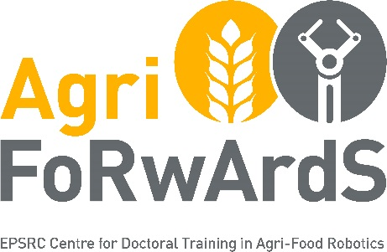

EPSRC Centre for Doctoral Training in Agri-Food Robotics: AgriFoRwArdS
Research Project / Presented Challenge Form: 2020-21 start

INDUSTRY TEAM DETAILS

INDUSTRY ADVISOR
Industry Advisor | Please provide: Name, Position, Organisation
Your skills and expertise

PROPOSED PRIMARY SUPERVISOR (Please note, primary and secondary supervisors should be from different partner universities in the CDT)
Preferred primary supervisor (if known) | Please provide: Name, Position, School, College, Research Group/Centre, email
Primary research area, skills and expertise required

SECOND SUPERVISOR
Preferred second supervisor (if known) | Please provide: Name, Position, School, College, Research Group/Centre, email
Primary research area, skills and expertise required

OTHER SUPPORT
Any additional internal support, external collaborators, etc.

POTENTIAL RESEARCH PROJECT / PRESENTED CHALLENGE DETAILS
Title of Research Project / Presented Challenge
Summary of Research Project / Presented Challenge | - Aims and Objectives  - Methodology  - Risk Mitigation
Fit with the CDT – please select the category which best fits with your Research Project / Presented Challenge
 |  |  | Mobile Autonomy
 |  |  | Manipulation & Soft Robotics
 |  |  | Sensing & Perception
 |  |  | Fleet Management
 |  |  | Human-Robot Collaboration
Skills we expect a student to develop/acquire whilst pursuing this Research Project/Presented Challenge

PROJECT ADVERTISEMENT

As well as forming the text for the project advertisement, this summary will also be used by the sift panel in conjunction with the information above to help assess the quality of the proposed project.
Research Project/Presented Challenge Advertisement Text (max 300 word) | Please provide a description that would be intelligible to suitable candidates and that addresses the following (you may use the same headers):  The wider context; why the project is important and timely  What are the expected benefits to the business/wider society  What precisely will the student do? Where? How?  Training (what opportunities will the student have? What skills will they gain?)
References | Please list up to five relevant references (these will also be included in the advertisement). These can include recent relevant papers/articles authored (or co-authored) by the industry or supervisory team.
Image For Advertisement | Please include a non-copyrighted image that we can publish with your advert on the AgriFoRwArdS website. You can paste this below, provide a hyperlink, or otherwise submit the image with your proposal.

Email the completed Project Proposal Form to: agriforwards.cdt@lincoln.ac.uk

