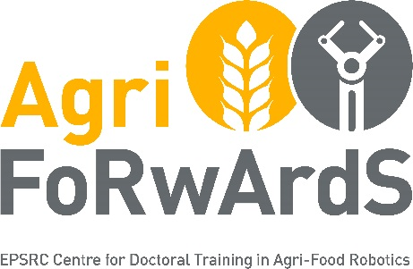

Supervisor Request Form
EPSRC Centre for Doctoral Training in Agri-Food Robotics: AgriFoRwArdS
Your Details
Name | Please provide: Name and title (e.g. Professor, Doctor)
Job Title
School/Department/College
Email Address
Primary research area, skills and expertise
AgriFoRwArdS Research Themes

AgriFoRwArdS addresses fundamental challenges in RAS technologies for both agriculture and food production. Research should focus on one of the following RAS component technology areas, including but not limited to:
Mobile Autonomy
Manipulation and Soft Robotics
Sensing and Perception
Fleet Management
Human-Robot Collaboration
Further information on potential research areas can also be found in the UK-RAS White Paper on the Future of Robotic Agriculture

How does your research fit in with the AgriFoRwArdS Research Themes?
300 words

Email the completed form to: agriforwards.cdt@lincoln.ac.uk who will forward it onto the relevant institution.
Please also use this email address if you have any queries.

Research areas should align with at least one of the above RAS component technology areas. Supervisor selection is subject to evaluation by the AgriFoRwArdS Scientific Board, which is made up of AgriFoRwArdS Co-Investigators based at the three partner Universities.

