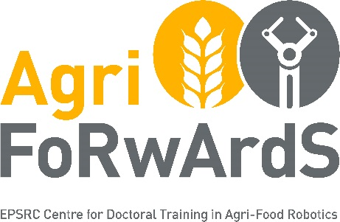

EPSRC Centre for Doctoral Training in Agri-Food Robotics: AgriFoRwArdS
PhD Project Proposal Form

SUPERVISORY TEAM DETAILS

PRIMARY SUPERVISOR
Primary Supervisor | Please provide: Name, Position, School, College, Research Group/Centre, email
Your primary research area, skills and expertise
Publications (list up to 4 relevant publications, published in the last 5 years)

SECOND SUPERVISOR (If available, or expertise sought – they should be from a different AgriFoRwArdS Partner Institution and have a different research focus to the first supervisor.)
Second Supervisor | Please provide: Name, Position, School, College, Research Group/Centre, email
Their primary research area, skills and expertise
Publications (list up to 4 relevant publications, published in the last 5 years)

INDUSTRY ADVISOR (If available, or expertise sought)
Industry Advisor | Please provide: Name, Position, Organisation
Their skills and expertise

OTHER SUPPORT
Any additional internal support, external collaborators, etc.

POTENTIAL CDT PROJECT DETAILS
TITLE OF PHD PROJECT
SUMMARY OF PROPOSED RESEARCH  (max 600 words) | - Aims and Objectives  - Methodology  - Risk Mitigation
FIT WITH RESEARCH STRATEGY &PLANS | - Fit with the remit for the CDT  - Outline anticipated outputs and impacts (max 250 words)
Potential industry partners for this project? Please name these and provide a short paragraph about each, including their fit with project and their financial contribution(s).
Skills we expect a student to develop/acquire whilst pursuing this project

PROJECT PITCH WORDING
As well as forming the text for the initial project pitch to students, this summary will also be used by the sift panel in conjunction with the information above to help assess the quality of the proposed project.
PROJECT PITCH TEXT (max 300 word) | Please provide a description that would be intelligible to AgriFoRwArdS MSc students and that addresses the following (you may use the same headers):  Scientific background (the wider context; why the project is important and timely)  Research methodology (what precisely will the student do? Where? How?)  Training (what opportunities will the student have? What skills will they gain?)
REFERENCES | Please list up to five relevant references (these will also be included in the advertisement). At least two of these must be recent relevant papers authored (or  co-authored) by the supervisory team.
IMAGE OR VIDEO FOR PITCH | Optional:  Please include a non-copyrighted image or video that we can share with the MSc students ahead of a pitch event. You can paste this below, provide a hyperlink, or otherwise submit the image with your proposal.

Curriculum Vitae of Primary Supervisor, included

Letter of Support, including financial contributions, included

Email the completed Project Proposal Form, Curriculum Vitae and Letter of Support to: agriforwards.cdt@lincoln.ac.uk

